Introducing an Efficient Sampling Method for National Surveys with Limited Sample Sizes: Application to a National Study to Determine Quality and Cost of Healthcare.

Additional file 1

Part A: Theoretical Aspects of Model-based Method
In mathematical notation, imagine you have data on several attributes (a matrix X which includes several variables for different individuals) and you want to classify these individuals into G homogeneous cluster which suitably shows all the differences in the data set. We can consider X as coming from a mixture of densities as follows:
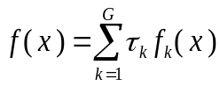
Where, fk is the probability density function of the observations in cluster k, and 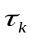is the probability that an observation comes from the kth cluster (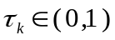 and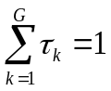). Each cluster is usually modeled by the normal or Gaussian distribution. The distributions in each cluster are characterized by the mean µk and the covariance matrix Σ_{k}, which has the following probability density function:
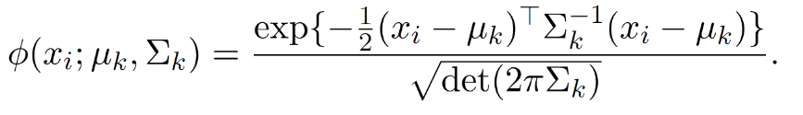
There are a number of possible parameterizations of Σ_{k}, some of them are parameterized to impose constraints across components. In practice, we selected the best model specification based on model comparison criteria such as BIC. We have used R programming language using “mclust” package to estimate the best set of clusters accordingly.

Part B: Comparison of Different Model-based Clustering Methods
Additional file 1 Figure 2: Comparison of different model-based clustering based on BIC criteria
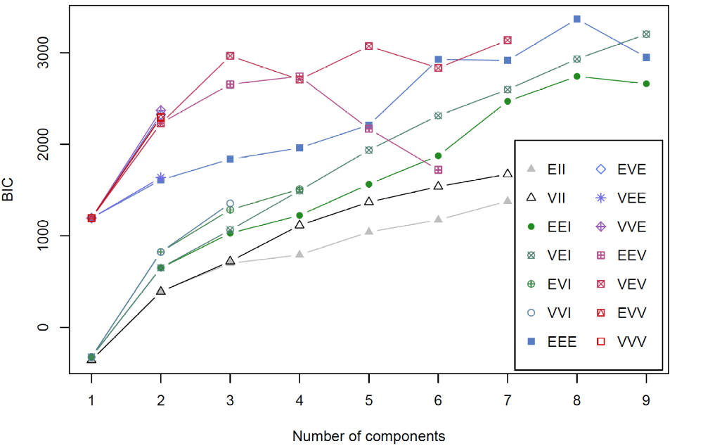
Note: Parameterizations of the covariance matrix $Σ_{k}$currently available in mclust ²⁸

Identifier | Distribution | Volume | Shape | Orientation
EII | Spherical | Equal | Equal | NA
VII | Spherical | Variable | Equal | NA
EEI | Diagonal | Equal | Equal | Coordinate axes
VEI | Diagonal | Variable | Equal | Coordinate axes
EVI | Diagonal | Equal | Variable | Coordinate axes
VVI | Diagonal | Variable | Variable | Coordinate axes
EEE | Ellipsoidal | Equal | Equal | Equal
EEV | Ellipsoidal | Equal | Equal | Variable
VEV | Ellipsoidal | Variable | Equal | Variable
VVV | Ellipsoidal | Variable | Variable | Variable

Part C: Clustering Results at Province Level
Since the input data is at the district level, MCM assigns districts into clusters. To generalize the clustering result at province level, we assigned province to a cluster that the majority of its districts (as also weighted by population size) fall into that cluster. To select one province from each cluster, we calculated the distance of each province from other provinces in the same cluster and selected the province with minimum distance from other provinces. This selection helps us to include a province which is a better representation of each cluster. The geographic distribution of MCM-8 at province level and the name of selected provinces are presented in Additional file 1 Figure 1 and Additional file 1 Table 1 respectively.
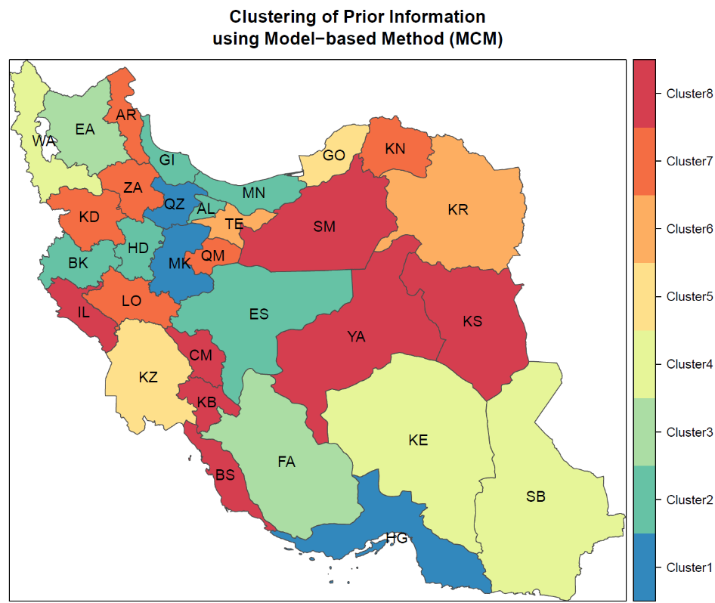
Figure 1: Geographic distribution of MCM-8 at the province level
Note: Markazi(MK), Gilan(GI), Mazandaran(MN), Azerbaijan-East(EA), Azerbaijan-West(WA), Kermanshah (BK), Khuzestan(KZ), Fars(FA), Kerman(KE), Khorasan-Razavi(KR), Isfahan(ES), Sistan-and-Baluchestan(SB), Kurdistan(KD), Hamedan(HD), Chahar-Mahal-Bakhtiari(CM), Lorestan(LO), Ilam(IL), Kohkiluyeh-and-Boyer-Ahmad(KB), BS(Bushehr), Zanjan(ZA), Semnan(SM), Yazd(YA), Hormozgan(HG), Tehran(TE), AR(Ardebil), Qom(QM), Qazvin(QZ), Golestan(GO), Khorasan -North(KN), Khorasan-South(KS), Alborz(AL)
Table 1: List of selected provinces by the proposed sampling method
Cluster number | List of provinces within each cluster | Name of selected province
1 | Markazi, Qazvin, and Hormozgan | Qazvin
2 | Gilan, Mazandaran, Kermanshah, Isfahan, Hamedan, Alborz | Gilan
3 | Azerbaijan-East, Fars | Fars
4 | Azerbaijan-West, Kerman, Sistan-and-Baluchestan | Azerbaijan-West
5 | Khuzestan, Golestan | Khuzestan
6 | Tehran, Khorasan-Razavi | Tehran
7 | Kurdistan, Lorestan, Zanjan, Ardebil, Qom, Khorasan -North | Lorestan
8 | Chahar-Mahal-Bakhtiari, Ilam, Kohkiluyeh-and-Boyer-Ahmad, Bushehr, Semnan, Yazd, Khorasan-South | Khorasan-South

